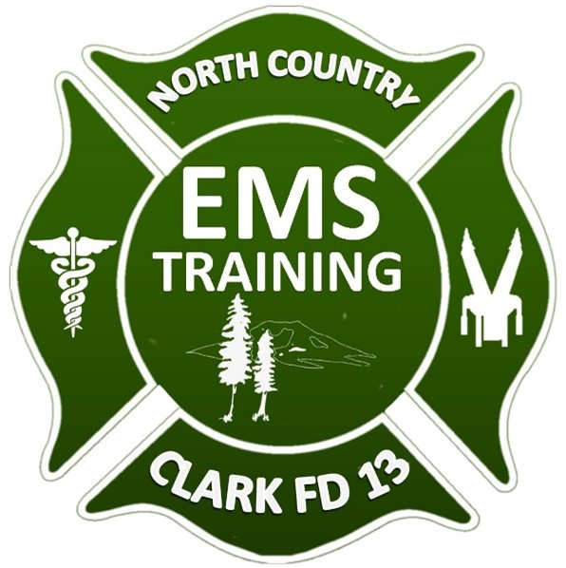

2025 North Country EMS Strategic Planning and Annual Training Plan

The 2025 North Country EMS Annual Training Plan (ATP) is designed to guide agency members on the training requirements and opportunities for the year. This plan establishes a well-rounded schedule covering essential topics and objectives to ensure all personnel are equipped to handle diverse disciplines and potential hazards encountered in NCEMS operations. The ATP includes core medical standards, specialty training, and real-time operational scenarios, applicable to all personnel, regardless of rank, while meeting the agency's competency and skill advancement goals.
The ATP may be adjusted throughout the year to integrate new training opportunities, support organizational goals, or address areas identified for improvement. Although managing the ATP is the responsibility of the Clinical EMS Chief, it is the daily crew whose flexibility and active participation make the ATP truly successful by incorporating training elements into their everyday duties to meet the agency’s operational needs.
- Training Approach
To meet the 2025 training requirements, the ATP offers a balanced approach across multiple areas, including:
- Emergency Medical Services
- Advanced Knowledge Classes
- Technical Scenarios
- Driver Safety
- Professional/Officer Development
The plan offers a structured framework for self-improvement and professional growth, with the primary goal of strengthening NCEMS’s response capabilities across its service area. We aim to manage emergency incidents safely and effectively by equipping personnel with advanced skills and knowledge.
- Alignment with Mission and Vision
The ATP ensures alignment with the agency's mission and vision:
- Mission Statement: Our mission is to protect lives, educate, and serve the residents and visitors of North Country EMS by providing professional, cost-effective emergency medical services in a community-focused system.
- Vision Statement: North Country EMS will be a model agency, recognized for its community focus, regional collaboration, and national reputation for excellence in emergency medical services and education.
NCEMS training prioritizes personnel safety, ensuring that each session enhances not only individual skills but also overall safety outcomes, both in training and during emergency responses.

- 2025 Training Requirements
The 2025 ATP outlines minimum training hours for each discipline, scheduling details, and training objectives to ensure clear expectations. This training plan enables department personnel to acquire the skills necessary to handle emergencies effectively and meet agency standards.

Annual Agency Training Objectives | Required Hours
PCEP / OTEP (ALS/BLS) | 24
Advanced Provider Training (ALS) | 12
Technical Courses | 9
Driver Operator | 8
Advanced Provider Training (BLS) | 6
Professional Development | 4
Distributive Education (ALS/BLS) | 12
Medic Off-Site Training (OR/ER) | 12
- Detailed Training Topics
- PCEP / OTEP (ALS/BLS): Mandatory paramedic PCEP lectures and case reviews, including OTEP training. BLS providers are encouraged to participate and will receive CME credit.
- Advanced Provider Training (ALS): Courses include the Paramedic Emergency Airway Course, ACLS, PALS, and PHTLS, offered annually. BLS providers are welcome to attend for CME credits.
- Technical Courses: LARRO, Vehicle Extrication, and Water Rescue awareness courses, conducted seasonally. Refreshers are provided as needed for operational readiness.
- Driver Operator Training: Includes distributive education, policy review, area familiarization, and adverse weather driving practices.
- Advanced Provider Training (BLS): Expanded training on EKG interpretation, supraglottic airway, and IV/IO labs.
- Professional Development: Courses supporting agency goals, such as EMS evaluator training, IV technician basics, and leadership development.
- Distributive Education: Includes labor and industry courses and any additional online training through the agency-provided learning management system.
- Medic Off-Site Training: OR training (4-8 hours once a year) and ER rotations (4 hours twice a year), per agency standards.
- Focus on Flexibility and Time Management
A core aspect of the ATP is balancing training time with flexibility, enabling personnel to maintain a broad range of skills while managing daily responsibilities. This approach reduces redundancy, ensures readiness, and sustains proficiency in low-frequency, high-risk areas. The monthly agency training objectives serve as a roadmap to effectively achieve annual goals. This plan underscores our commitment to excellence and safety, empowering our team to perform with skill and confidence in every situation.
- Enhance Care through Quality Improvement through Retrospectives
- Identifying Trends: Analyzing past incidents helps identify trends in patient care and recurring challenges, allowing for adjustments in protocols and training.
- Enhancing Decision-Making: Reviewing cases provides insights into the decision-making processes of personnel, highlighting areas for improvement.
- Improving Protocols: Retrospectives reveal the effectiveness of existing protocols, leading to necessary revisions for better patient outcomes.
- Fostering Continuous Improvement: Regular retrospectives encourage a culture of learning and open discussion about mistakes and successes.
- Strengthening Training: Insights from retrospectives can inform targeted training that addresses identified weaknesses.
- Enhancing Communication: Involving multidisciplinary teams in retrospectives improves collaboration and communication, leading to better patient care.
- Monitoring Performance: Retrospectives provide a framework for tracking key performance indicators (KPIs) related to patient care and service effectiveness.
- Incorporating Feedback: Gathering feedback from personnel involved in past incidents enriches the understanding of what works and what needs improvement.
By systematically reflecting on clinical practices, North Country EMS can create a feedback loop that enhances patient care and operational efficiency.
- Assess the need and potential integration for a Community Paramedic-Inspired Care Program
Assessing the need for integrating community paramedic skills is important for many reasons:
- Targeted Interventions: It ensures resources are focused on specific health challenges where they’re most needed.
- Improved Health Outcomes: Identifying care gaps helps improve health outcomes, especially for high-risk populations.
- Enhanced Service Delivery: Helps optimize services, improving response times and patient care.
- Community Engagement: Involves the community, fostering trust and collaboration.
- Resource Allocation: Enables better allocation of resources where they’ll have the greatest impact.
- Crisis Prevention: Focuses on preventive care, reducing emergency visits, and improving overall health.
- Informed Decision-Making: Provides data for evidence-based decisions.
- Adaptability: Helps the service adapt to changing community needs.
- Cost-Effectiveness: Reduces healthcare costs by preventing unnecessary emergencies.
In short, assessing the need ensures services are effectively tailored to community health challenges, leading to better care and outcomes.

